Booth Algorithm

Name: 劉怡安

**Description:**

* Algorithm

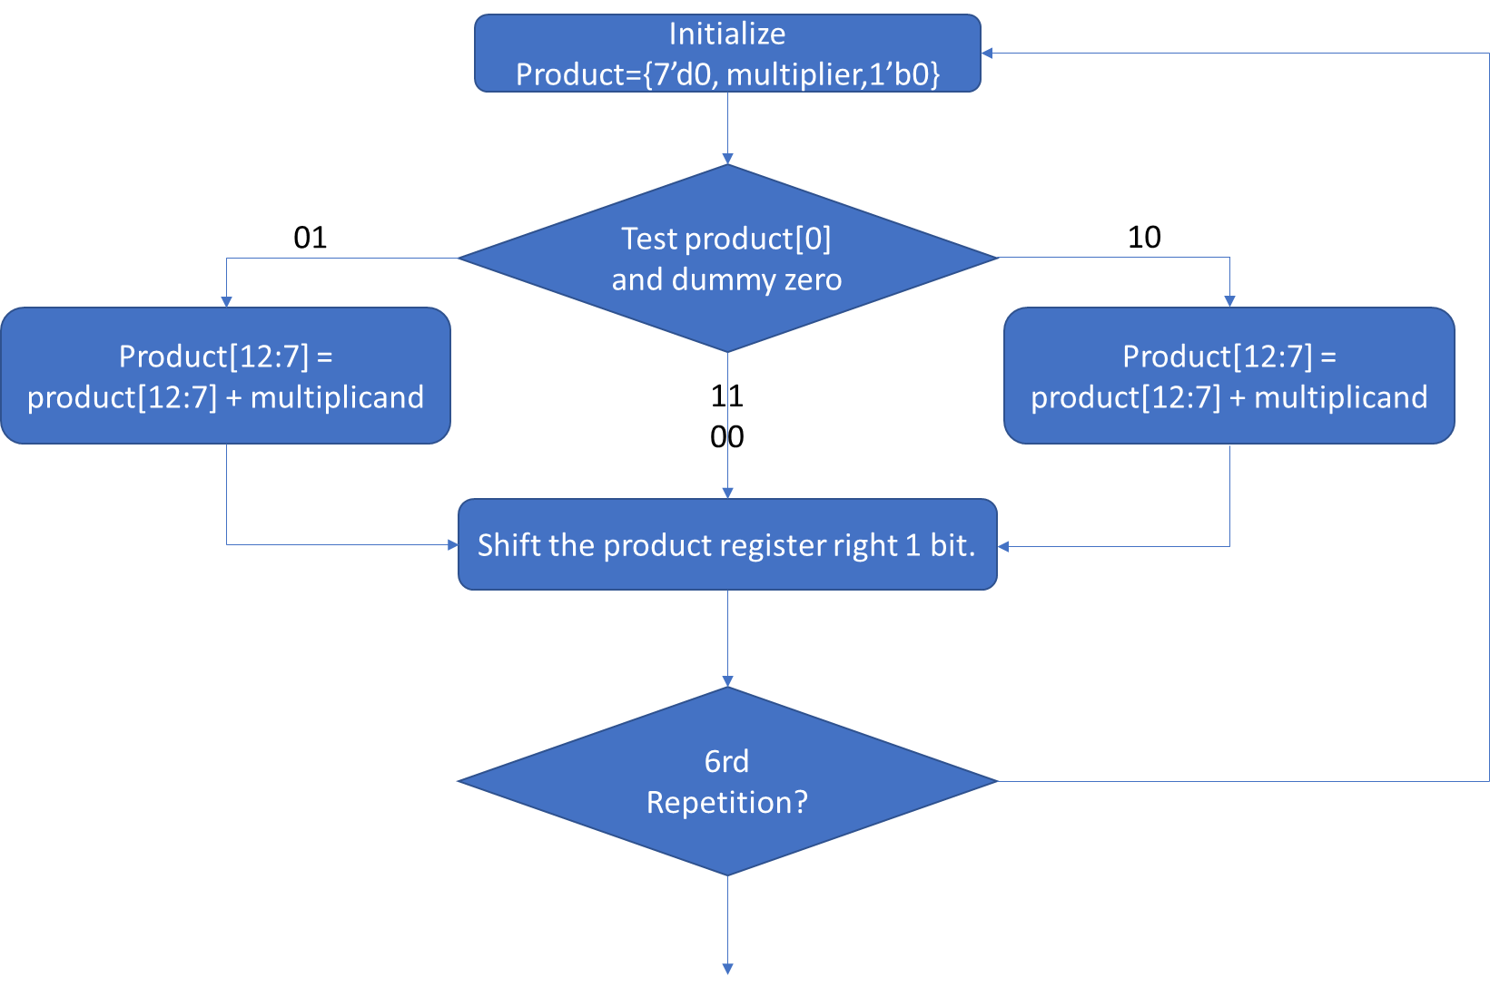

* Control Data Flow Graph

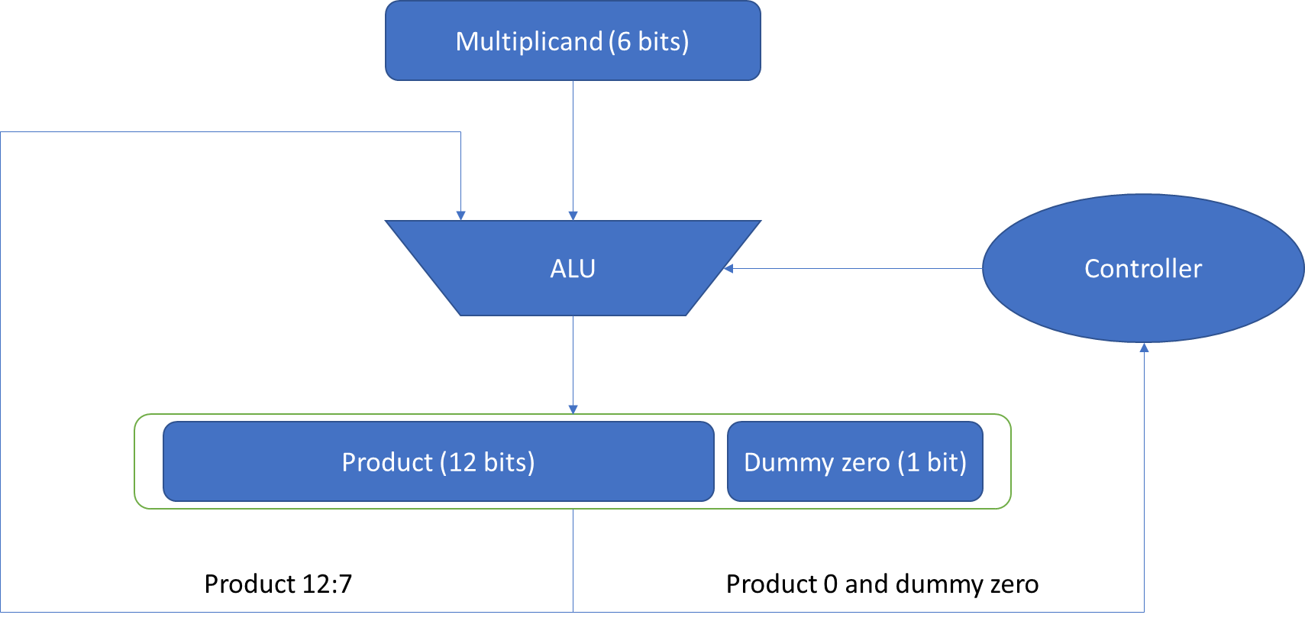

* Simulation

